 | Monday | Tuesday | Wednesday | Thursday | Friday
Recess 10:25-10:55 | JP Playground  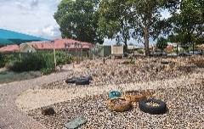  (Ms Carly/Ms Karuna)  (Rec-Year 2) | JP Playground  (Ms Karuna/Ms Carly)  (Rec-Year 2) | JP Playground  (Ms Carly/Ms Isabella M)  (Rec-Year 2) | JP Playground  (Ms Karuna/Ms Kelly)  (Rec-Year 2) | JP Playground  (Ms Kelly/Ms T)  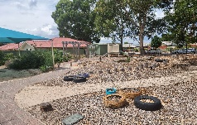  (Rec-Year 2)
Lunch 12:55-1:25 |   Library Activity  (Ms Alisha) |   Lunchtime Sport  (Mr Ralph)  Courts/Oval | Lunchtime Sport  (Mr Ralph)  Courts/Oval | Library Activity  (Ms Hayley) | Library Activity  (Ms Phillips)
Term 1 break time activities

